Exercise 2: Implementing the Factory Method Pattern
Factory Method Pattern
The Factory Method Pattern is a creational design pattern that provides an interface for creating objects without specifying their exact classes.
It allows object creation to be delegated to subclasses, making the code more flexible and easier to maintain.
Applications of Factory Method Pattern
- Document Management Systems
- Report Generation Systems
- Database Connection Management
- Notification Systems
Implementation
Document.java
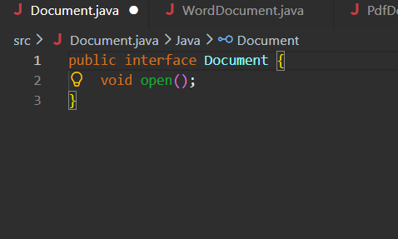

DocumentFactory.java
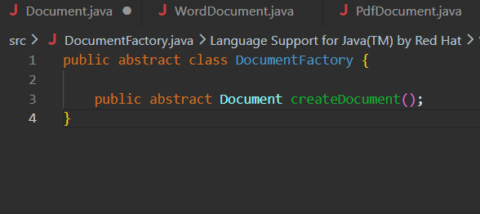
ExcelDocument.java
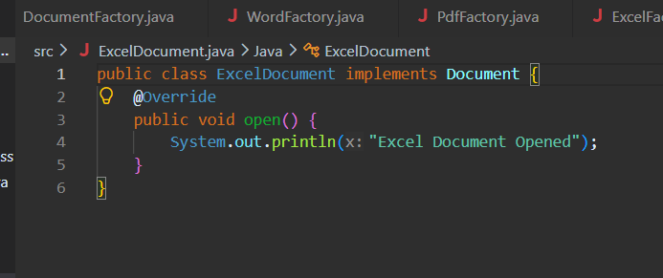

ExcelFactory.java
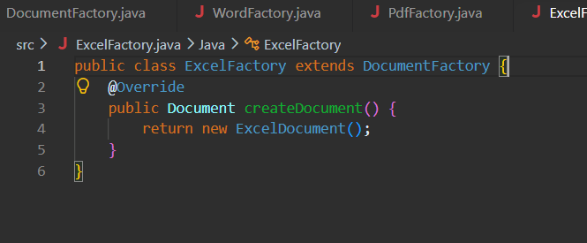

PdfDocument.java

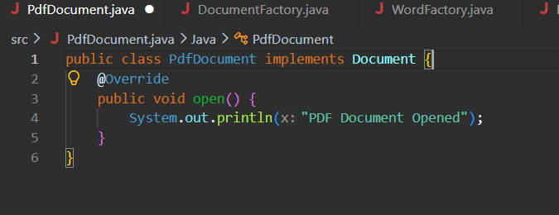
PdfFactory.java
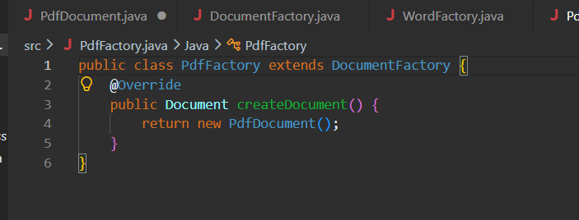
WordDocument.java
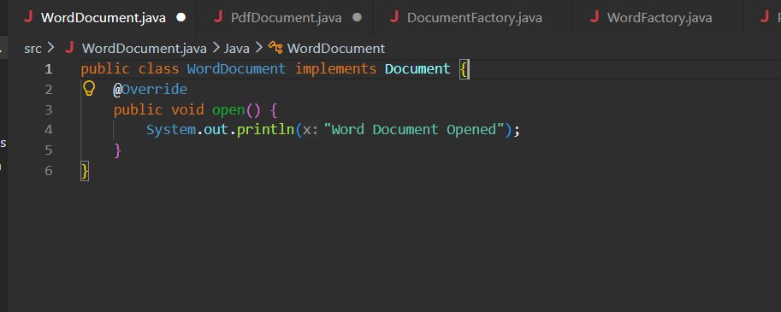
WordFactory.java
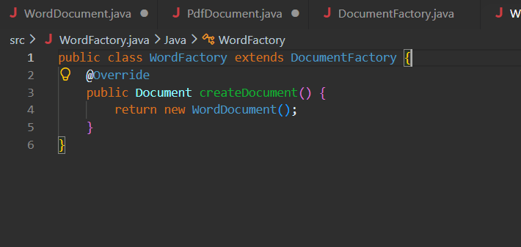

DocumentTest.java
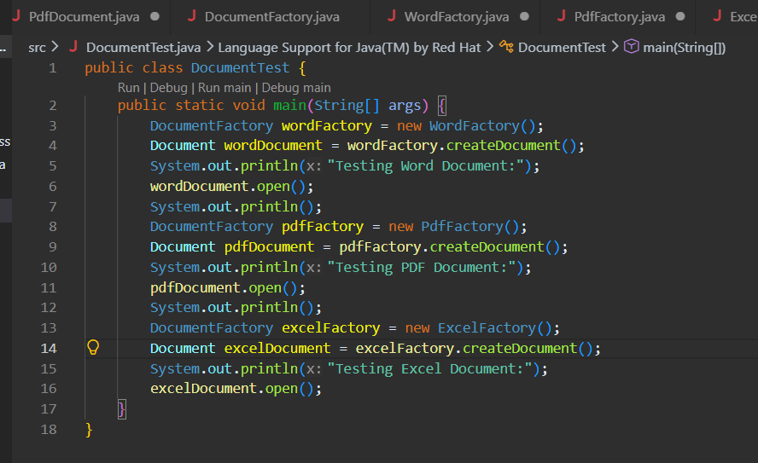

OUTPUT
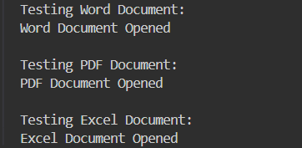

Analysis
- The client does not directly create document objects.
- Object creation responsibility is delegated to factory classes.
- New document types can be added without modifying existing code.
- Improves flexibility and maintainability.

